**Azure DevOps Introduction:**

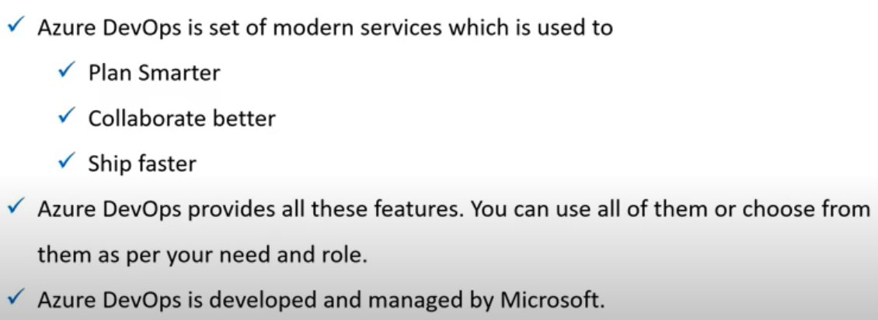

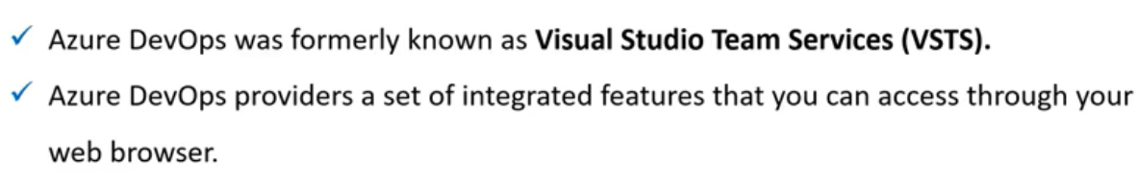

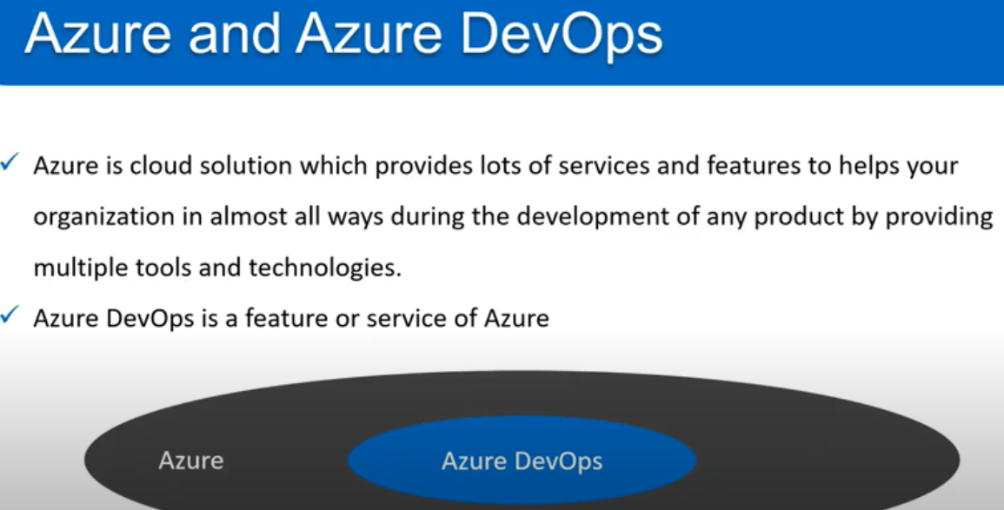

**Azure devops services:**

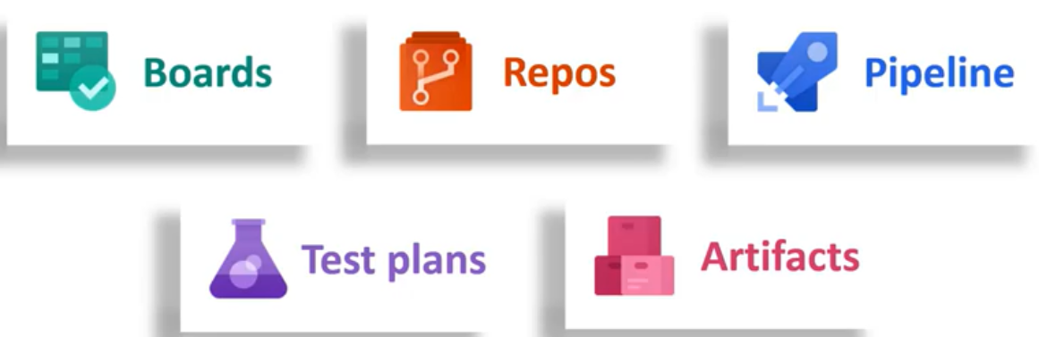

* Boards are used to plan the work. We can write about the tasks, bugs etc..
* Repo is to store the code. We can TFS repo or git etc and manage the code. We can manage branches and all. We can use all the features of git.
* Pipeline is used for CI/CD purpose. We can build and deploy the code with pipeline.
* We can have test related info in test plans.
* Artifacts is used to store the packages of the code.

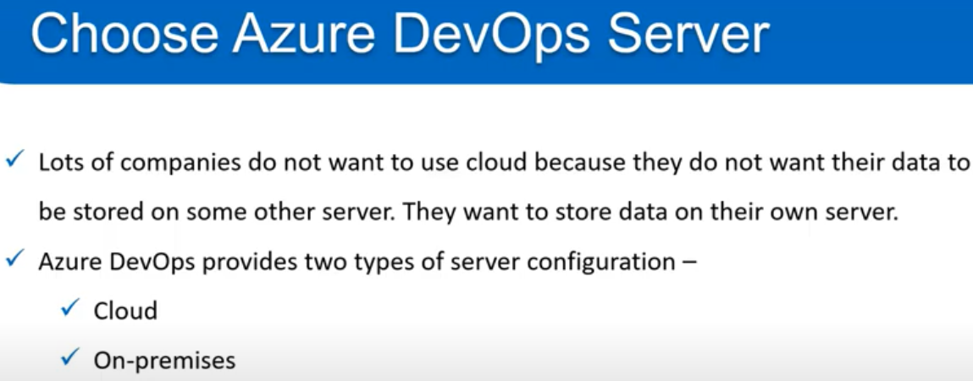

* If we don’t want to use the cloud server in azure devops. We can use on premises server also.

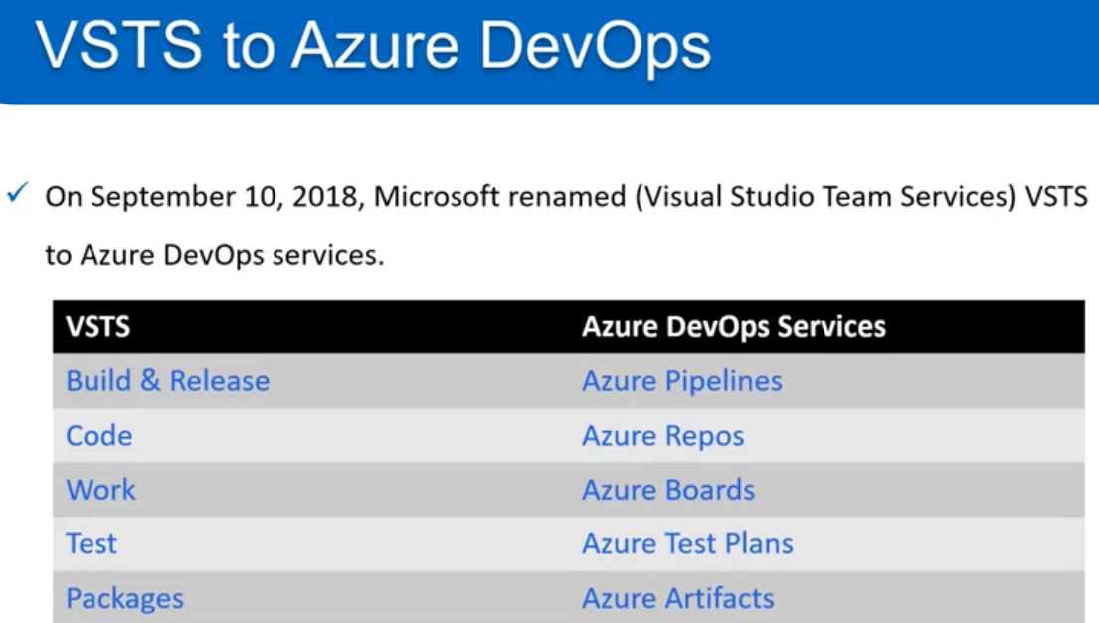

**Global notifications:**

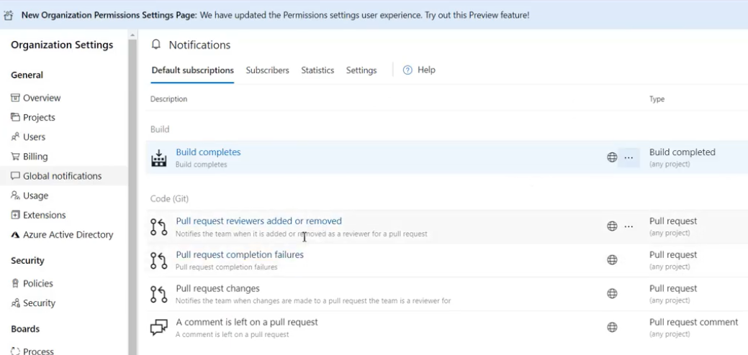

We can add/disable the global notifications as above.

**Usage:**

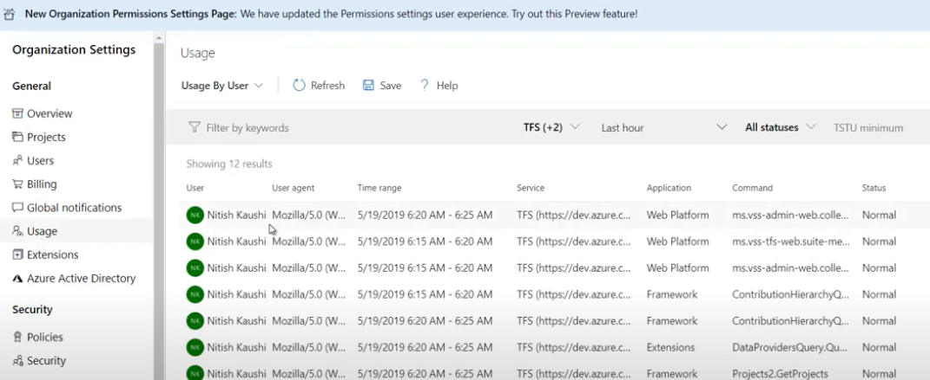

Here we can see what user is doing what in azure devops.